Second Avenue UMC
801 E. Second Avenue, Rome, GA 30161
Community Resource Guide
Rev. Millie L. Kim

Daycare/Childcare:
- PALS Preschool & Kindergarten@Trinity UMC
- Rome First UMC Preschool & Kindergarten
- Berry College Child Development Center
- Amberwood East Preschool
- Kid’s Stop Learning Center
- Bush Reach For The Stars
- Bright Horizons
- Oak Bridge Academy
- Rebecca Blaylock Child Development Center
- Kid’s World Learning Center
- Toddlers Inn
- Winthrop Academy
- Kiddie Corral
- Terri’s Daycare

Schools in the Zip Code 30161:
- St. Mary’s Catholic School (Private)
- Darlington School (Private)
- Unity Christian School (Private)
- Montessori School of Rome (Private)
- E. Central Elementary School
- Johnson Elementary School
- Model Elementary School
- Main Elementary School
- North Heights Elementary School
- McHenry Primary School
- Rome Transitional Academy
- Rome Middle School
- Rome High School
- Model Middle School
- Model High School

Colleges & Universities:
- Berry College
- Shorter University
- Georgia Highlands College
- Georgia Northwestern Technical College

Churches:
- Second Avenue Baptist Church
- First Baptist Church
- First Christian Church
- First Presbyterian
- Rome First UMC
- Trinity UMC
- Metropolitan UMC
- St. Peter’s Episcopal Church
- St. Mary’s Catholic Church
- Salem Reformed Church
- Lovejoy Baptist Church
- Thankful Baptist Church
- North Rome Church of God
- North Broad Baptist Church
- Seventh Day Adventist Church
- Rodeph Sholom Congregation
- TLV Bible Fellowship
- Korean Presbyterian Church of Rome
- Eglisia De Dios Evangelio Completo

Grocery Stores:
- Kroger, 1476 Turner McCall Blvd, 706.290.8039
- Publix, 435 Turner McCall Blvd, 706.291.3380
- Aldi, 836 Turner McCall Blvd
- Walmart Supercenter, 825 Cartersville Hwy, 706.292.0838

Fitness Centers:
- YMCA of Rome/Floyd County 810 E. Second Avenue 706.232.2468
- Velocity Fitness 515 E. Second Avenue 706.291.6040
- Workout Anytime Rome 132 Hicks Drive, SE 706.405.3363
- Crossfit Rome 314 E. 1st Avenue 706.906.0176
- Vitality Fitness Center 504 Redmond Road 706.290.2334

Health and Wellness Programs for Senior Adults:
(The following wellness centers and programs provide an array of programs, including exercise classes, exercise equipment, and health education classes.)
- Area Agency on Aging of Northwest GA 706.295.6485, nwgrc.org (The Area Agency on Aging sponsors programs to promote good nutrition, physical activity and lifestyle management. Living Well, a Chronic Disease Self-Management Program, helps persons with chronic health conditions learn how to actively self-manage their health. Meets once weekly for six weeks. A Matter of Balance program helps older adults to reduce their fear of falling and to increase their activity level. The group meets once weekly for eight weeks.)
- Georgia Golden Olympics 770.867.3603, goldenolympics.org The Georgia Golden Olympics is a statewide event for adults 50 years of age or older. The event provides an opportunity to participate in amateur sports competition, to learn new leisure skills, to discover that physical activity is for all ages, to meet new friends and to share good times. A variety of activities and age divisions make it possible for participation regardless of an individual’s age or physical ability.
- Silver Sneakers/Parker Center 706.234.0383, rfpra.com/spec-senior.htm An upbeat fitness class geared for adults 50 and over. Classes are free with the Silver Sneakers card provided by many health insurance plans.

Health and Safety Education
- American Red Cross– NWGA Chapter 706.291.6648, www.redcross.org/ga/rome Provides health and safety education programs for the public; first aid, CPR, swimming and life guarding; CNA training, Babysitter’s Training, and Family Caregiver educational training. ARC provides education in disaster preparation and offers disaster relief services to families affected by house fires or larger disasters, such as tornadoes and floods. They also aid in emergency communications between military personnel and family members.

Educational Opportunities (College and University-Based Programs)
These outreach programs are designed to challenge, educate and enrich the lives of persons in the community. Persons are not required to be an enrolled academic student to take advantage of these educational opportunities.
- GA Northwestern Technical College Continuing Education 706.295.6958, gntc.edu
- UGA County Extension Service 706.295.6210, caes.uga.edu/extension/floyd
- Berry College Senior Scholars Program at Oak Hill 706.368.6789, oakhillmuseum.com

Libraries:
- Rome-Floyd County Library 706.236.4600, shrls.org
- Northwest Georgia Talking Book Library Georgia Libraries for Accessible Statewide Services (GLASS) supports accessible library services in Georgia by promoting the use of assisting technology and by providing accessible reading materials to those who, due to a disability, are unable to read standard print. 1-800.248.6701. www.georgialibraries.org/glass/

Georgia Department of Veterans Services – Floyd County Field Office 201 Calhoun Avenue, Rome 706.295.6026 Department of Veterans Affairs – Regional Office 800.827.1000, veterans.georgia.gov

Health Clinics and Health Centers:
- Floyd County Clinic Provides out-patient primary medical care sick residents of Floyd County with very low income who have no form of health insurance.
- Faith & Deeds Community Health 706.234.1331 www.faithsanddeedshealthcare.org Volunteers provide primary health to persons with low income who have no form of health insurance, including Medicare or Medicaid.
- Floyd County Public Health Department 706.295.6123, nwgapublichealth.org The health department offers general public health services, including blood pressure checks, flu and pneumonia immunizations, diabetic nutrition counseling, breast and cervical cancer screening, vision and hearing checks, children’s health services, etc.

Hospitals/Medical Centers:
- Willowbrooke at Floyd 306 Shorter Avenue, NW Rome, GA 30165 706.509.3500
- Floyd Medical Center 304 Turner McCall Blvd., 706.509.5000, floyd.org
- Redmond Regional Medical Center 501 Redmond Road, 706.291.0291, redmondregional.com
- Kindred Hospital of Rome 304 Turner McCall Blvd., 706.509.4100, kindredrome.com A long-term acute care hospital specializing in wound care, ventilator weaning and also rehabilitation to medically complex patients.
- Coosa Diagnostics 16 Riverbend Drive, 706.378.0611, diagnosticsystemsofga.com
- Coosa Medical Group 126 Three River Drive, 706.295.0070, romephysician.com
- Harbin Clinic 1825 Martha Berry Blvd., 706.295.5331, harbinclinic.com

Psychiatric Hospitals:
- Willowbrooke at Floyd 306 Shorter Avenue, NW Rome, GA 30165 706.509.3500
- Highland Rivers Floyd County Mental Health Center 706.233.9023

Dental Clinics:
- Floyd County Public Health Department 706.802.5050
- Georgia Highlands Dental Hygiene School 706.295.6760
- Georgia Baptist Mobile Dental Van at Floyd County Baptist Center 706.291.8181, floydbaptist.net Visits Floyd County once a year from Georgia Baptist Health Mobile. Local volunteer dentists provide basic dental services, fillings and extractions.

Rehabilitation Programs:
- Acute Inpatient Floyd Medical Center Inpatient Rehab 706.509.6610, floyd.org
- Redmond Regional Medical Center Inpatient Rehab 706.291.0291, redmondregional.com
- Kindred Hospital of Rome 706.378.6800, kindredrome.com

Rehabilitation Programs, Sub Acute Inpatient:
- Chulio Hills Health and Rehab Center 706.235.1132, reliablemgt.com/chulio-hills-health-rehab
- Etowah Landing Care and Rehabilitation Center 706.235.1337, genesishcc.com/Etowah
- Evergreen Health and Rehab 706.378.3383, evergreenhrc.com
- Fifth Avenue Health Care Center 706.291.0521 reliablemgt.com/fifth-avenue-health-care
- Rome-Health and Rehabilitation 706.234.8281, www.saveasenior.com
- Pruitt Health of Rome (formerly Summit Health and Rehab) 706.236.6002, pruitthealth.com
- Winthrop Health and Rehab 706.235.1422, winthrophealth.org

Rehabilitation Programs, Outpatient:
- Advance Rehabilitation of Rome 706.235.2727
- Floyd Medical Center Outpatient Rehab Services 706.509.3400, floyd.org
- Redmond Outpatient Rehabilitation Center 706.236.1911, redmondregional.com
- Redmond Regional Medical Center Cardiac Rehab 706.368.8386, redmondregional.com
- Rome Rehabilitation Center 706.802.0780

Assisted Living Facilities:
- Brookdale Rome Assisted Living 706.234.1655, www.brookdale.com
- Riverwood Senior Living 706.235.0807
- Grace’s House 706.777.8040
- Grace’s House Two 706.295.7084
- Renaissance Marquis Retirement Village 706.295.0014, renaissancemarquis.com
- Riverwood Senior Living 706-706.235.0807, riverwoodretirement.com
- Manor house 706.802.0990, romancourt.com
- Winthrop Court Senior Living 706.236.2500, winthropseniorliving.com
- Seven Hills Place 706.232.5244

Memory Care/Alzheimer’s/Dementia Care:
- Manor House 706.802.0990
- The Harbor at Renaissance Marquis 706.295.0014, renaissancemarquis.com
- Riverwood Senior Living 706.235.0807, riverwoodretirement.com

Nursing homes:
- Chulio Hills Health and Rehab Center 706.235.1132, reliablemgt.com
- Evergreen Health and Rehab 706.378.3383, evergreenhrc.com
- Fifth Avenue Health Care Center 706.291.0521, reliablemgt.com
- Rome Health and Rehabilitation 706.234.8281
- Pruitt Health Rome 706.236.6002, pruitthealth.com
- Etowah Landing Care and Rehabilitation Center 706.235.1337, genesishcc.com
- Winthrop Health and Rehabilitation 706.235.1422

Hospice Care:
- Affinis Hospice 866.991.1998, affinishospice.org
- Amedisys Hospice 866.313.1217, amedisys.com
- AseraCare Hospice 800.974.4677, 770.698.8785, asceracare.com
- Heartland Hospice 866.873.6308, heartlandhospice.com
- Heyman HospiceCare at Floyd 706.509.3200, floyd.org
- Hospice Compasses 770.218.1997, hospiceadvantage.net
- Hospice of Chattanooga 800.267.6828, hospiceofchattanooga.org
- Mt. Berry Hospice 706.232.1571, mtberryhospice.com
- North Star Hospice 706.403.4033, northstarhospice.com
- Regency Hospice 770.529.8155, regencyhospice.com
- Tapestry Hospice 706.383.8812
- Transitions Hospice Care 877.781.2273, regencyhospice.com
- Pruitt Health Hospice 706.236.4704, uhs-pruitt.com

Food Pantry:
- Bagwell Food Pantry 706.291.7731
- Floyd County Baptist Center 706.291.8181
- Garden Lakes Baptist Church 706.234.6615
- Helping Hands Food Pantry 706.232.0277
- Lovejoy Baptist Church 706.232.1917
- Metropolitan United Methodist Church 706.291.8660
- Salvation Army 706.291.4745
- West Side Family Worship 706.291.0293

Feeding Programs/Soup Kitchen:
- Good Neighbor Ministries 208 East Second Street, Rome 9:00-11:30 AM, M-F. Come in person for a referral to a Rome Action Ministries food pantry: Bread of Life, Bagwell Food Pantry or Garden Lakes Baptist Church. Applications for Christmas food baskets are accepted the week after Thanksgiving. Meals and More at First Christian Church 706.291.6745, Provides free take-out meals on Tuesdays at 5:00 PM; 209 E. Second Ave at 3rd St.
- One Harvest Food Ministries Church at Northside: 770.749.8761 Greater Christ Temple: 706- 232-1959 Distributes food through area host sites. Cost is $35/box of groceries or $27/ten cooked meals to heat and serve. No eligibility restrictions. Call for order info. Menus online at: oneharvest.com
- Rome Action Ministries Community Kitchen Churches serve free hot meals at the corner of North Broad Street and Calhoun Ave, 4 Calhoun Ave. M-F, 11:00 AM-12:30 PM. South Broad Feed the Hungry Churches offer free sack lunch, one Saturday per month, 11:00 AM, South Broad Baptist Church, 508 South Broad Street. Thanksgiving Love Feast – Rome 706.234.2091
- The Floyd County Senior Center and Nutrition Program Provides free lunch, Monday through Friday, for persons age 60 or older. They also offer social activities and wellness programs. 706.291.0760

Independent Retirement Communities (Non-Subsidized):
- Renaissance Marquis Retirement Village 706.295.0014
- Riverwood Senior Living 706.235.0807
- The Village at Maplewood 706.290.9123

Subsidized or Income Based Apartment Communities for Senior Adults:
- Etowah Terrace 706.622.4598
- Greystone Apartments 706.232.5798
- Heatherwood Apartments Ltd 706.235.2881 NW
- Georgia Housing Authority High Rise 706.291.0780
- Villas 706.235.6881

Subsidized or Income Based Apartment Communities:
- Ashland Park 706.290.1040 Ashton Ridge Apartments 706.802.0017
- Callier Forest Apartments 706.291.2936
- Meadow Lane Apartments 706.235.3355
- Pine Ridge Apartments (Exclusively for homeless or potentially homeless disabled adults.) 706.235.0360.
- Riverwood Park Apartments 706.235.7666
- Spring Haven Apartments 706.777.9600

Homeless Shelters
- Salvation Army 706.291.4745
- William S Davies Shelter 706.512.1152
- Hospitality House for Women 706.235.4673

Parks:
- Benty Jones Park, 212 E. 13th Street, Rome. GA 30161
- Ridge Ferry Park, 393 Riverside Pkwy, Rome, GA 30161
- Parks Hokes, 200 Hardy Avenue, Rome, GA 30161
- Riverside Park, 1 Redwood Street, NE, Rome, GA 30161
- Northside Swim Center, 501 Kingston Avenue, Rome, GA 30161
- Lock Dam Park & Campground 706.234.5001
- “The Pocket” Recreation Area 706.638.1085
- Rocky Mountain Recreational Area 706.802.5087
- Heritage Trail, tredromefloyd.org

Bookstores:
- Barnes & Noble 1442 Turner McCall Blvd., Rome, GA 30161 706.232.3202
- Dogwood Books 240 Broad Street, Rome, GA 30161 706.235.2660
- Alan’s Used Books 407 B Broad Street, Rome, GA 30161 706.295.2665
Rome-Floyd Parks and Recreation Center 1 Shorter Avenue, rfpra.org 706.291.0766

Floyd County Senior Center 406 Riverside Pkwy., 706.291.0760

Floyd County DFCS 706.295.6500, floydbaptist.net

Church Vicinity:
On Turner McCall there are over 10 Fast Food Restaurants within 3 blocks of the intersection of Turner McCall Blvd and E. 8th. On Second Avenue where we are located, we are surrounded by residential housing units, professional offices (doctors, dentists, Edward Jones, Farm Bureau), banks, YUMC, and Pottery Studio. All the billboards advertise Sports, Hospitals, church, no fast food advertisement.

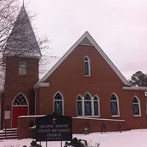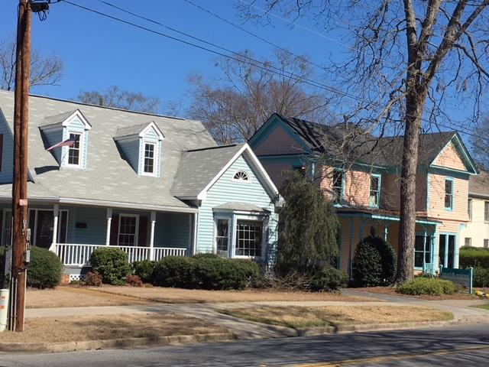
Church On the other side of E. 8th (right across from the church)
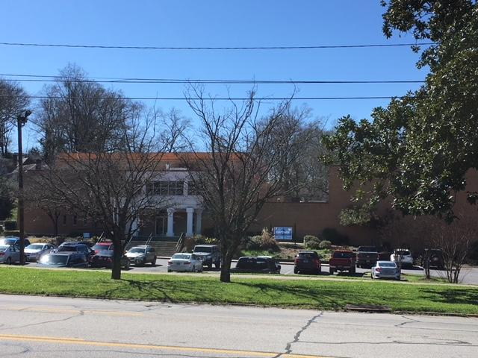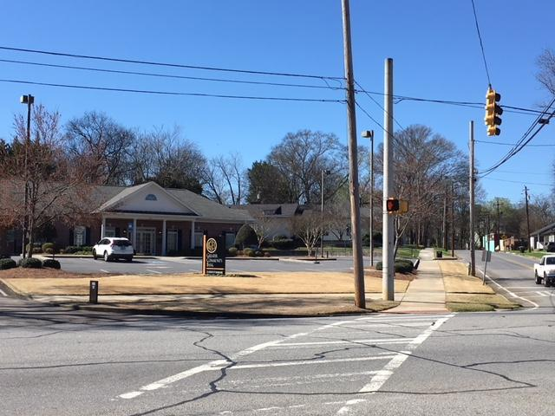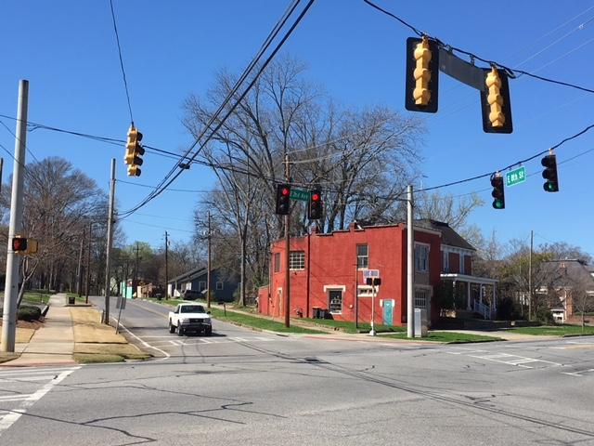
E 8th and Second Avenue (YMCA, 1st pic, Bank, 2nd pic, right across the church on Second Avenue, Red Brick Bldg, 3rd pic, a Pottery Studio, located diagonally from church)

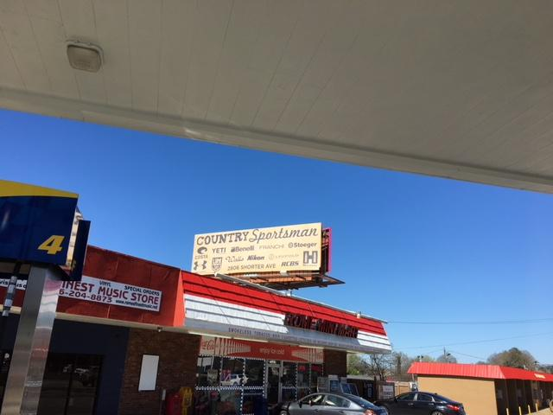
A nearest billboard from church advertising Sports Store/Outfitter)

